# Government of Karnataka



Department of Collegiate & Technical Education

GOVERNMENT POLYTECHNIC

DEPARTMENT OF COMPUTER SCIENCE & ENGINEERING

# Chitradurga-577501

**2023-24**

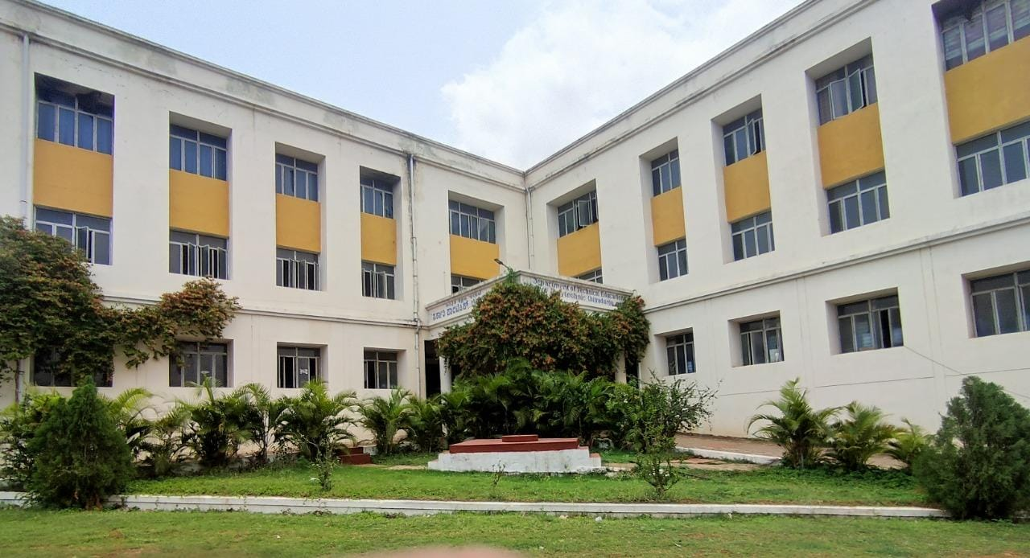

**COURSE NAME & COURSE CODE: PROJECT ON FULL STACK DEVELOPMENT (20CS62I)**

REPORT ON:

CONTINUOUS INTERNAL EVALUATION ( I , II & III )

**Mrs. Nayana R, BE, M TECH Mr . Suresh T S, BE, M TECH**

Cohort-owner, CS&E Dept. Program Coordinator, CS&E Dept.

Govt. Polytechnic, Chitradurga. Govt. Polytechnic, Chitradurga.

**Mr. B. Ramesh , BE, M TECH**

Principal

Govt. Polytechnic, Chitradurga.

***SUBMITTED BY:***



|  |  |  |
| --- | --- | --- |
| **SL NO** | **NAME OF STUDENTS** | **REG NO** |
| **01** | **SHESHAGIRI S** | **149CS21046** |
| **02** | **DIVYA J** | **149CS21021** |
| **03** | **DILEEP P** | **149CS21020** |
| **04** | **DHANYASHREE A P** | **149CS21019** |

**\*\*\*\*\*\*\*\*\*\*\*\*\*\*\*\*\*\*\*\*\*\*\*\*\*\*\*\*\*\*\*\*\*\*\*\*\*\*\*\*\*\*\*\*\*\***

